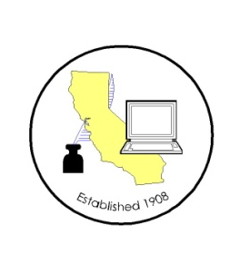
CALIFORNIA ASSOCIATION OF

CLERKS AND ELECTION OFFICIALS

July 9, 2012

TO: CACEO Members, Guests, Legislative Committee

FROM: Deborah Seiler and Jill LaVine, Co-Chairs

SUBJECT: CACEO LEGISLATIVE COMMITTEE MEETING

DATE: TUESDAY, July 17, 2012

TIME: 1:00 p.m. – 3:00 p.m.

LOCATION: Sheraton San Diego Hotel and Marina (Catalina Room)
Annual Conference

AGENDA

1:00 pm Welcome and Introductions

Approval of April 20, 2012 minutes

Updating NVRA – presentation of SB 35 by Lori Shellenberger, Civic Engagement Attorney, ACLU

Discussion of Bills
AB 867 Swanson, am. 6/26
AB 1436 Feuer, am. 6/18
AB 1805 Huffman, am. 7/6
AB 1814 Eng, am. 5/25
AB 1851 Allen, am. 4/24
AB 1929 Gorell, am 6/28
AB 2058 Pan, am. 5/17
AB 2080 Gordon, am. 6/26
AB 2452 Ammiano, am. 5/8 (enrolled)
SB 1233 Padilla, am. 6/11
SB 1272 Kehoe, am. 6/27
SB 1275 Lieu, am. 4/24

